SHORT COMMUNICATIONS

CREATING "ZERO" IN THE AMHARIC /GE’EZ NUMERIC SYSTEM
Amdework Mitiku

1. BACKGROUND

Amharic is the official language of Ethiopia and uses a script derived from the ancient Ge'ez alphabet. Legend has it that the Amharic/Ge'ez script was transformed into alphabet in the fourth Century by monks of the Ethiopian Orthodox Church. Apart from being rich and legendary, the Amharic/Ge’ez script is also used in several other Ethiopian languages. The Amharic numeric system, however, doesn’t have a “zero”.

A few years ago, this writer started a project called "Introducing 'zero' in the Amharic/Ge’ez numeric system". Thinking about this concept first occurred to the author one afternoon while attending a new class called "Digital Electronics". At that time, even though having taken several classes in electricity and science, the digital electronics concept was new and hard to grasp. That day the professor had to spend the whole class time just talking about "0" and "1".

The "Digital Electronics" class was not confined to simply talking about "1" and "0" as an academic exercise, but it was also concerned with the widespread implications of binary digits in today’s technological revolution. Given the powerful impact of binary digits, one could not help wondering how long it would be before the Amharic/Ge’ez numeric system stopped borrowing numbers form the English language for mathematics, science, engineering, and several other applications.

There is no way to apply this marvelous concept of digital electronics to the Amharic/ Ge’ez numeric system, unless one borrows a symbol for "0" from another number system. But that was what exactly one sees in Amharic newspapers, personal letters, magazines and several works of literature.

It was therefore necessary to introduce the concept of, and a symbol for, "0" in the Amharic/Ge’ez numeric system. Some people may never think about the existence of "zero" in the Amharic/Ge’ez language, or one might laugh out loud and say "What the hell is he talking about?" Alternatively, I thought, some may be as intrigued by this concept as I was, and send me some feedback. That was exactly what I got from my family members, friends, coworkers and other people who read and heard about my idea. Even though I got a mixed message, most people supported my idea.

Soon after, the central idea of the project was posted on the Internet, with the promise of following up with some in-depth coverage at a later stage. Ever since the first step, the response obtained was beyond expectations. Part of the reason for this might be the ease to communicate with so many people around the world without leaving the computer desk.

However, up to this point, the author’s own response to the feedback has not been as prompt as initially envisaged because of time constraints. The author believes the opportune moment has now come to share ideas with everyone.

2. THE AMHARIC/GE’EZ NUMERIC SYSTEM

Like any other widely used language, it is possible to write and read Amharic/Ge’ez numerals with out significant problems. However, the Amharic/Ge’ez numeric system does not start from zero. Instead, it starts from the number "one" and goes to large numbers. The Amharic/Ge'ez numeric system has specific symbols which correspond to the Arabic numerals "1", "2", "3", "4", "5", "6", "7","8", and "9". The problem, however, concerns numbers which consist of two or more digits, one or more of which may be a "zero".

The ancient Ethiopians got around this problem by inventing specific symbols for numbers like 10, 20, 30, 40, 50, 60, 70, 80, 90, 100, 1000. This was an ingenious way of circumventing the problem, but the difficulty is that such a system involves more than twenty basic symbols, or roughly twice as many as is the case in the English numeric system. Thus, when a person wants to write any number which has more than one digit, he/she has to use a combination of one or more symbols. For instance, "twelve" would be represented in English by writing "1" followed by "2"; in Amharic, this is done by writing the symbol for "10" followed by "2". Likewise, if one wanted to represent "thirty-four" in the Amharic number system, he/she would have to use the symbol for "30", followed by "4", rather than writing "3" followed by "4". Or, if the value in question is, say, "one hundred forty-five", this is represented by writing the symbol for "100" followed by the symbol for "40", followed by the symbol for "5", rather than writing "1" followed by "4" and "5". In the Amharic numeric system, there is no possibility of denoting zero, decimal or negative values. Probably, 3000 years ago, nobody worried about representing "zero," because "0" is empty or null. Even today, it is not readily apparent to the average person why "0" is significant, because it stands for "nothing". In reality, however, "0" is a powerful number, and today’s society is highly dependent on its representation. It is worth pointing out that the significance of "0" during the Roman Empire was not the same as the role it has come to play in the 21st century.
3. AMHARIC “ZERO”

One thing is clear, if there is no "0", there will be no digital application. So, how can the Amharic/Ge’ez numeric system participate in an increasingly digital world? Well, the answer may be simple and logical.

I still remember what I learned in my elementary school Amharic course about the nature of language. Language, I was taught, is like a living creature, and it will pass three main stages--it will be born, grow and, if it is not properly nurtured, die. So if we do not act on time, sooner or later, part of our language will "go down to the drain". To be more blunt, unless certain measures are taken, the Amharic/Ge’ez numeric system will face its last stage; it will die; its fate is in the hands of its users. Introducing "0" into the Amharic/Ge'ez numeric system will popularize the language.

The foregoing discussion focused mainly on the implications of the situation with respect to digital technology. However, while it was the most compelling reason that provided the impetus for this project, it is by no means the only reason.

Soon after I came up with the idea, I started reviewing documents in Amharic, including newspapers, magazines, and personal letters. I even went as far back as my elementary, junior and high school days. I could not remember a single attempt by any one in school to use the Amharic/Ge’ez numeric system in mathematics, science or any other courses as a means of expressing numeric value. The classes I took, the papers I read, the prices I saw in markets and shops, the menus that I was shown in restaurants, and several other texts written in Amharic did not use the Amharic/Ge’ez numeric system. The only exception to all this has been the fact that Ethiopian calendars tend to use both the Arabic and Ethiopian numeric symbols. But why?

An Amharic speaker or someone who knows about it may observe the limited use of the Amharic numeric system to certain areas only. One can write days, months, years, page numbers and a few other things using Amharic/Ge’ez numeric symbols; it is unimaginable to use Amharic numerals to perform arithmetical operations at ease. We do not also have symbols for numbers such as 0.5, 0.001, -12, -14.05 and so on, which are less than zero. So, what is the solution?

Something that allows the use of this great language in today’s computational society is necessary. Having "0" or “bado” in the Amharic/Ge’ez numeric system will make the numeric system compatible with all languages.

4. CHOICE OF THE SYMBOL FOR ZERO

After comparing several promising symbols, the one which came closest to satisfying the following three criteria was adopted: the symbol to be adopted has to be easy to create, easy to remember, and closely related to existing symbols.

Taking out the two horizontal lines from the top and the bottom, the new symbol for the Amharic zero looks like θ. In most cases, this symbol looks like the symbol used for an "empty set or null". Since "zero" is related to "empty", people will relate the symbol with it and will not find it difficult to remember in the real world. The symbols for "four" and "nine" in the Amharic/Ge’ez numeric system, show some resemblance between with the new symbol. "Four" looks like an O, with two horizontal strikes, one at the top, and one at the bottom. Likewise, the symbol for "nine" is like θ, without a top horizontal strike, or a U with a horizontal strike in the middle. Thus, examining the physical characteristics of the Amharic symbols for "4" and "9", many similarities will be found with the symbol for the Amharic zero newly adopted. By combining the physical characteristics of these two numbers and the logical meaning of the symbol, the new Amharic "zero" symbol was created, see below.

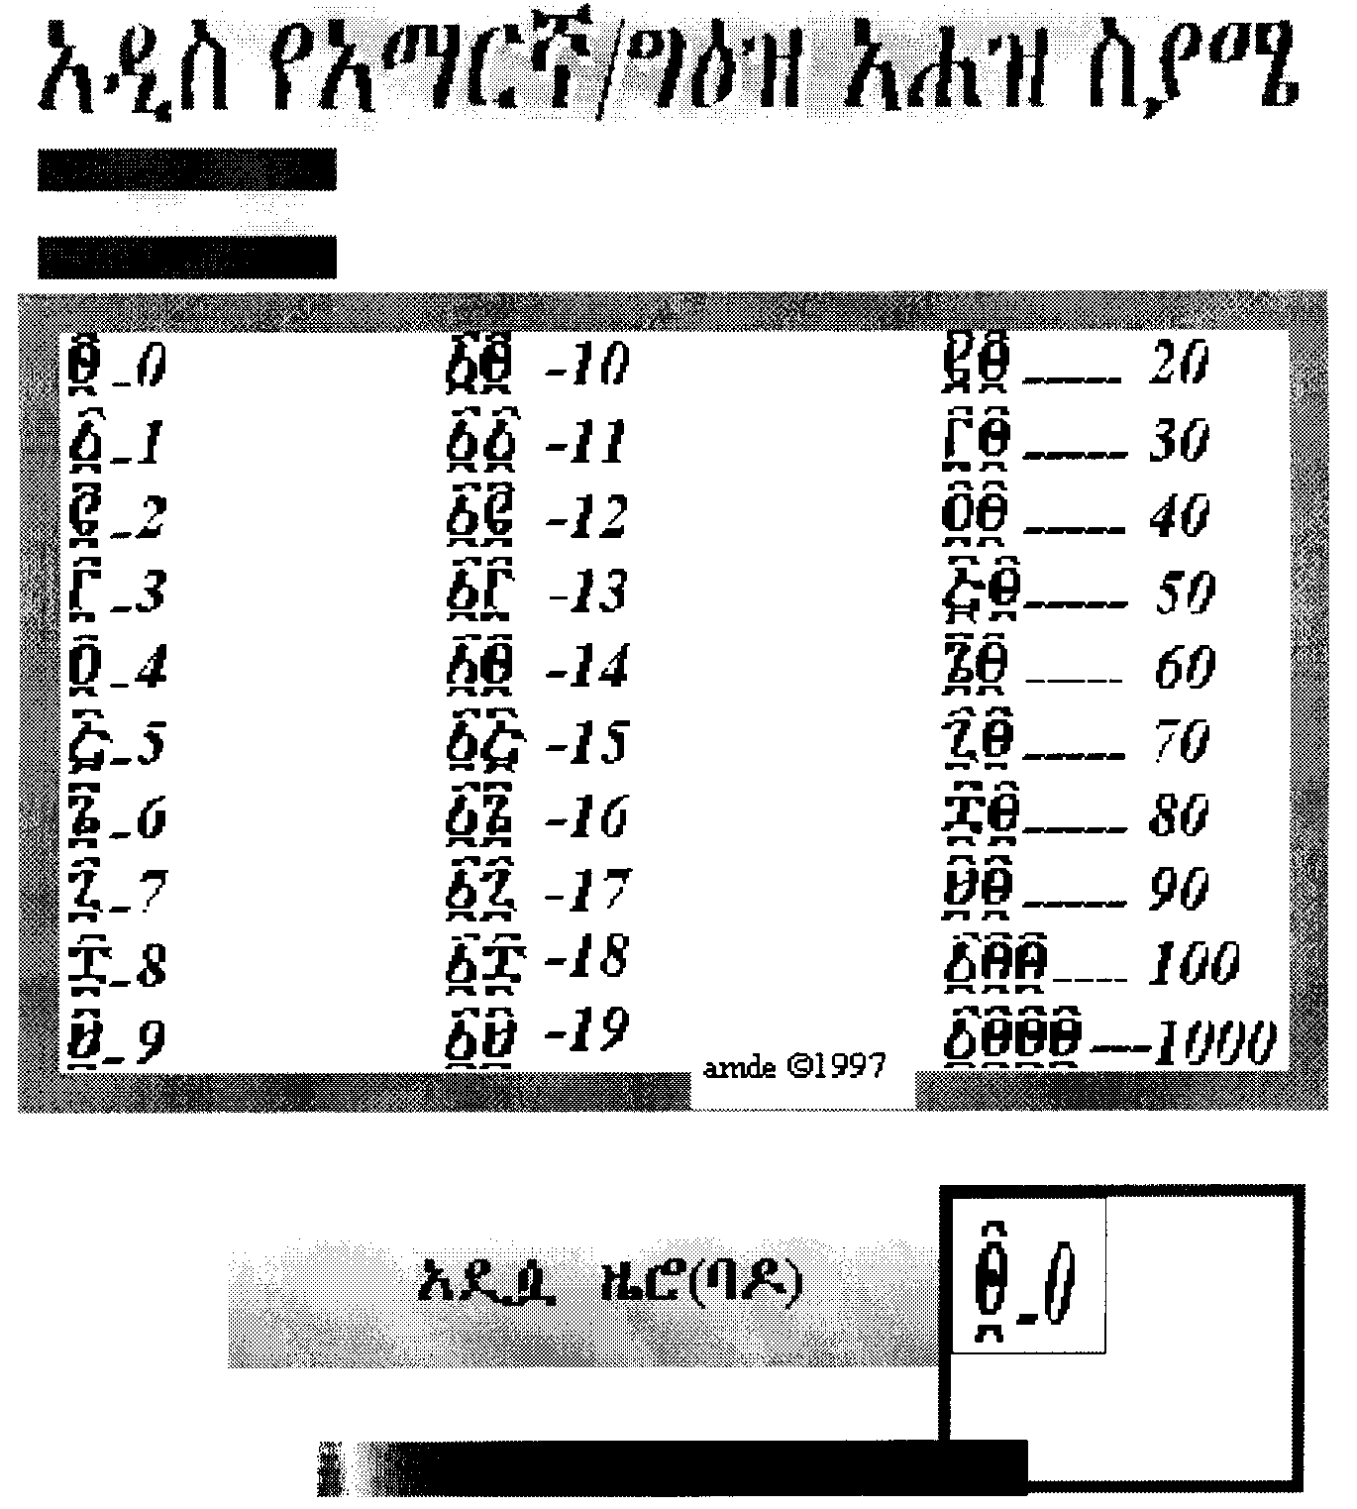
The new character is also easy to write. One of the difficult things in the Amharic numeric system is the complexity of forming the characters, compared to the Arabic/English numeric characters. In contrast, writing the new symbol for "zero" will not involve that much complexity. All that a person has to do is draw a circle, draw a horizontal diametrical line, and add two additional horizontal lines, one at the top and another at the bottom.

5. CONCLUDING REMARKS

Before starting this project, interviews were made with several people that included native Amharic speakers. Most of these people did not have any idea about the status of "0" in the Amharic/Ge’ez numeric system although they know the impact of "0" in today’s society. Consequently, a mixed reaction was received from each group. Some of the people responded it was not a good idea to alter the language for the sake of technology. Others felt the idea might save the Amharic numeric system from disappearing.

The interviews also showed that people over 40 can read almost all Ge’ez/ Amharic numeric characters, and have few problems on writing. People who are between the age of 30 and 40 are in the middle; more than half of them can read and write the numeric system with minimal error. On the other hand, when I asked people who are between the ages of 20 and 30 to read these numbers, they did so only with considerable difficulty. Moreover, when I asked them to write any number, the result was disappointing. I found out that some people do not even want to see or talk about these numbers. These numbers are vanishing from the minds of such groups of people. People under 20 were the same as people between 20 - 30. As I did not expect these people to come up with a better response than the others, I got the result I expected; it was not good.

In my survey I took the geographical location, family, school, culture, religion and other points as factors which contribute to differences in the level of exposure to the Amharic/Ge'ez numeric system. For example, I did not expect to get the same answer from someone who took classes in a church school or from someone who was heavily influenced by the traditions of the Ethiopian Orthodox Church as from a person who went to a Catholic school. Going to the traditional school called "Kes Timihirt Bet", which is equivalent to a modern pre-school, makes a big difference. Many of my contemporaries and I had to pass through this system at an early age, and people who went to these schools perform better than others who did not. My survey took this as a big factor. I never blame any person for not knowing the language as expected, but I blame some others. I think these groups are the one who will take the blame.

Educational institutions from pre-school to post graduate levels bear a major responsibility for failing to promote the Amharic/Ge'ez numeric system assiduously enough. The Ministry of Education, teachers, and those parents who are members of school committees could have enforced the introduction of the indigenous numeric system more extensively. But they did not do it in the past and are neither doing it still today. If taught, we could have applied it anywhere. However, there is no single school spending a 50-minute class on the Amharic numeric system.

The second blame may go to the Ethiopian media, which includes the TV and radio enterprises as well as magazine, books and newspaper producers. These groups have not tried fairly enough to capture attention and encourage the use of the Amharic number system as part of day-to-day life. In this respect, the editors of the Amharic newspapers like "Addis Zemen" and "Yezarytu Ethiopia" are to be thanked for using the indigenous numeric system on a regular basis. There are many other magazines published in Amharic; but, unfortunately, it looks as if they have purged the Amharic numeric system from their computers or printers, as all of them use the English numeric system in documents published in Amharic!

The Amharic/Ge’ez numeric system is a unique treasure to preserve. Amharic is a survivor; it has endured and developed for the last 3000 years. By adding this new symbol to the numeric system, the system will be enriched and brought to compliance with all other modern numeric systems. This, in turn, will allow Amharic numerals to be compatible with modern science and technology, and provides the necessary impetus for people to use it more extensively than at the moment. The Amharic number system should be used at ease in any scientific or mathematical operation. A symbol for "zero" will signify a major breakthrough in this respect allowing the Amharic/Ge’ez numeric system compete with other number systems.

In contrast to Amharic/Ge’ez letters which are widely used and not in any danger, the Amharic numeric system is becoming less popular among the new generation. Protecting Amharic numerals from the danger of extinction is therefore a shared responsibility.

ACKNOWLEDGEMENTS
The Author presents special thanks for those who helped to make the project tangible and Dr. Adamu Walelign for editing the lengthy article and the support through feedback and valuable advice.

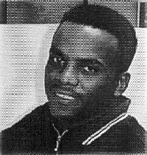 BS in Electrical and Computer Engineering, California State University, San Diogo; B.Sc. from the Addis Ababa University in Electrical Engineering.
Amdework Mitiku
Yebbo Communication Network
P.O.Box ………………………
San Diego,
California - USA
Tel. ………………………….
E-mail: amde@yebbo.com or amdenet@yahoo.com

Software Engineer at GAMMA-METRICS in San Diego, California; Worked at the PPIC (Processing of Poly Industrial Chemicals), Addis Ababa; Founder (owner) and senior web developer at Yebbo communication Network: http://www.yebbo.com; Founder of three web sites www.Ethiopia.NU, www.thearkofthecovenant.com and www.jfk.nu; www.ewin200.com (coming soon).

One of the founders and active members of EPAN (Ethiopian Professional Associations Network (http://www.yebbo.com/ EPAN); one of the founders of Ethiopian Technical and Graduated Students Association; active member of NSBE (National Society of Black Engineers); active member of IEEE (Institute of Electrical and Electronics Engineers); supporting the campaign against malaria and AIDS/HIV in Ethiopia.

VARIOUS COMMENTS ON
“CREATING ZERO IN THE AMHARIC/GE'EZ NUMERIC SYSTEM”

Re: Creating Zero in Amharic/Ge'ze numeric system
From: Nadew. You are looking into one of the most important aspect of our number system. As we all are aware, our numeric system doesn’t have a zero symbol or it doesn’t offer a trend that symbolizes zero. Getting a symbol that everyone agrees to is not a problem. We can take the Geez number one and find a symbol that is closer to it to be designated as zero. By the way, are we going to change all the other numbers like 10, 20, 100, etc?

This issue is bigger than what it seems. In addition to the number problem, we don’t have the binary representation of our alphabets and numbers. In the continued development of the digital technology we better have some thing better than a simple code that is mapped to Geez fonts. Having a program that works with the English keyboard may seem to be “killing two birds with one stone”. However it is not the complete solution to incorporate our language with the digital technology. Let’s hope there are enough technologists who would like to work towards creating a standard for a complete binary solution to our language.

Re: About Creating "Zero" in Ge'ze Numeric System!!
From: Elias. Just to say a great thinking. I wish I had some suggestion how to name the "Zero". If I were you I will name a single value that makes sense to me. You are a creator and inventor. Believe me no one will argue what symbol you use because nobody thought about it before you. Again keep up your great work

Re: Creating Zero In Amharic/Ge'ezÊ Numeric system
From: Amharic98, From Ethio.com. Hi Amda, I visted your web at http:// kahuna.sdsu.edu/~mitiku/. What you are trying to do is a great idea. As you said, to use commercially available seven segments LCD to display Amharic language numeric system would be very difficult without some adjustment.

Since you asked for suggestions, I would like to offer one. In order to display our numeric system on the commercially available seven segment LCDs, we need to make three small changes to our numeric system. This is not a bad idea in itself; Western numeric system made similar changes when it was first introduced to the LCD system. For example two = 2 and seven = 7 had to be little adjusted to fit in the seven segment LCD system.

The first adjustment: dropping the two lines that occur on top and bottom of every Amharic numeral. Since these lines are common for all numerals, dropping them doesn’t make them look different. Lets assume the lines are there by default.
If we drop the two lines, we can display the whole of Amharic numerals on an LCD except the numbers two, six and seven. For the latter two, I suggest the following until a better alternative is sought, what do you think?

The second adjustment: when you look the Amharic six, the offending part is the top line that points leftward. One way to solve this problem is to make the top line point to the opposite side, just like the Amharic three, and use one hybrid.

The third adjustment: our seven looks like the Western Z without the two lines on the top and bottom. As you know, you can not display Z on seven segment LCD. So, for time being, lets cut the bottom line and make it look like 7 until we find another alternative.

I think, if you like these three adjustments, then you can display the whole Amharic numeric system on commercially available 7-segment LCDs without any further adjustment on the LCD's. (Invitation to o http://abalone.phys.cwru.edu/tutorial/enhanced/files/ lcd/address/address.htm for the LCD sytem. )

ANOTHER ALTERNATIVE : if you do not want any compromise, then you should use 40 CHARACTER * 2 LINES BUILT IN LSI HD44789 CONTROLLER. This HITACHI DOT MATRIX LCD MODULE gives you individually controlled capability of 5 columns by 8 rows. This means you can turn on and off individually each column and row to create any thing you like. Good luck!!

To see LM018L Display Pattern and Character Set, to see the whole chart, click on page down buttonhttp://lenel01.uni-mb.si/~toni/datasheets/lcd /lm018l/display.html. If any body has a better idea please feel free to add to this great project.

Re: Creating Zero in Amharic/Ge'ze numeric system
From: EthioNet. I know someone who is working on this idea under his basement for the last few years. You better hurry to come up with your solution before it is too late to put your name on the patent. if you need help let me know!!!!!!!!!!

Re: Creating Zero in Amharic Language.
HEY AMDE, THIS IS YONNY: GET THIS - ETHIOPIA HAS NEVER BEEN POOR IN THE GOOD OLD TIMES. THAT IS WHY WE DO NOT HAVE ZERO IN GEEZ. NOW, SINCE WE ARE GETTING POORER, WE NEED ZERO AND THE ONE THAT YOU SHOWED ME LOOKS GOOD TO ME. GOOD DAY.

CALL FOR PAPERS AND GUIDELINES FOR AUTHORS

Message from the Editorial Board

The SEEE∗ Journal of Electrical Engineering (SEEE JEE), a publication of the Society of Ethiopian Electrical Engineers, is a wide-scope Journal ON:

- Electronics and Microelectronics;
- Computer software and hardware;
- Instrumentation, Measurement and Metrology;
- Control and Automation;
- Power and Energy Conversion;
- Communication;
- Electro-Physics and Electromagnetism;
- Signal Processing and Telecommunications;
- Electrical Engineering Education; and,
- Other branches of Electrical Engineering and related fields.

SEEE JEE publishes scientific articles (full papers) and short communications. Also entitled for publication are product and literature reviews, tutorials, correspondence concerning information published in previous issues and topical scientific information as may be recommended by authors. The language of the Journal is English.

Title of article should be brief and contain full name of the author(s) An abstract precedes body of the manuscript. Papers should be reasonably subdivided into sections and, when necessary, subsections. For full scientific articles, the next scheme is proposed.

- INTRODUCTION

The subject-matter of the article should be defined clearly; short review of published relevant solutions and comparison with results obtained should be given.

- THEORETICAL PART

The author presents his considerations and ideas, mathematical formulae and their derivation. All information taken from other authors or critical comments on other works should be accompanied by exact references.

- EXPERIMENTAL PART

Includes data on measuring method and instruments as well as experimental results. In a purely theoretical work, this part is omitted.

- DISCUSSION

Presents critical analysis, interpretation and evaluation of obtained results.

- CONCLUSION

Results should be summarized briefly, showing explicitly scientific contribution of the author(s).

- REFERENCES

Should be fully and accurately documented and conform to standards used in other journals. References should be quoted in the text in square brackets and listed at the end of the paper in the order they appear in the text.

- AUTHOR(S) BIOGRAPHY

The recommended content shall be:

- full name (titles, in parentheses);
- current address;
- degrees (year, in parentheses) and fields;
- work experience in brief;
- interests and activities;
- former and present affiliations; and,
- any other pertinent information.

Short communications need not have all sections mentioned for full scientific articles. As usual, however, contribution of the author(s) should be stated explicitly at the end of the communication.

Preferred width of figures is one column or, exceptionally, two columns (not exceeding 7.5 or 16 cms, respectively). The use of ARIAL font is prescribed. We recommend black and white photographs.

After evaluation by two independent peer reviewers, sending the final version at nsec@telecom.net.et or post office box 5722 c/o the NSEC, fax 251 1 601818, Addis Ababa, Ethiopia, is highly encouraged. Hard and/or soft copies may be delivered in person at the Departmental Office of the Electrical Engineering Department, Faculty of Technology, Amist Kilo, telephone 12 25 30.

Authors will receive free issue of the Journal.

The Editorial Board, SEEE JEE

 SEEE, pronounced “es – triple – e”, is an acronym for the Society of Electrical Engineers, P.O. Box 385, Addis Ababa, Ethiopia.

